Registered No. WB/SC-247 No. WB(Part-I)/2006/SAR-285
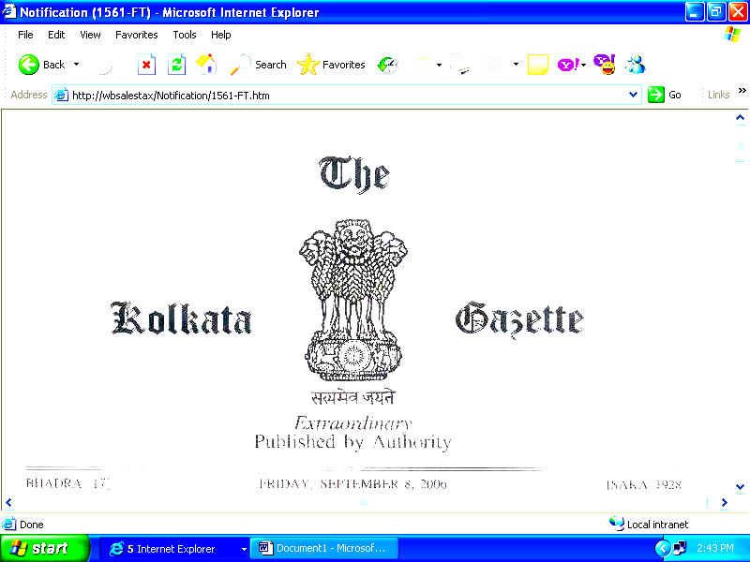
AGRAHAYANA 24] FRIDAY, DECEMBER 15, 2006 [SAKA 1928

PART I - Orders and Notifications by the Governor of West Bengal, the High Court, Government Treasury, etc.

GOVERNMENT OF WEST BENGAL

FINANCE DEPARTMENT

Revenue

NOTIFICATION

No. 2039 – F.T. – the 15th December, 2006. – Whereas the draft of amendments to amend Schedule A, and Part I, Part II and Part III of Schedule C, to the West Bengal Value Added Tax Act, 2003 (West Ben. Act XXXVII of 2003), as subsequently amended (hereinafter referred to as the said Act), was published as required under section 20 of the said Act vide notification No. 1871 – F.T., dated the 15th November, 2006, in the Kolkata Gazette, Extraordinary, dated the 15th November, 2006, for the purpose of inviting objections or suggestions from all persons likely to be affected there within fourteen days from the date of its publication;

And whereas the objections and suggestions received in this regard have been duly considered by the Government;
Now, therefore, in exercise of the power conferred by section 20 of the said Act, of Governor is pleased hereby to make the following amendments:-

Amendments

In the said Act, -
- in Schedule A, -
      - after serial No. 2 in column (1) and the entry relating thereto in column (2), insert the following serial No. in column (1) and the entry relating thereto in column (2) :-
“2A. Alluric Acid.”;
(b) in column (2) against serial No. 23A, in column (1), insert the following entry :-
“Lac and Shellac.”;
(c) in item (i) in column (2) against serial No. 37A in column (1), for the words “artificial silk”, substitute the words “silk, artificial silk”;
- in Schedule C, -
(a) in Part I, -
- after serial No. 5A in column (1) and the entry relating thereto in column (2), insert the following serial No. in column (1) and the entry relating thereto in column (2) :-
“5B. All knids of rope.”;

2 THE KOLKATA GAZETTE, EXTRAORDINARY, DECEMBER 15, 2006 [Part I

(ii) after serial No. 8A in column (1) and the entry relating thereto in column (2), insert the following serial No. in column (1) and the entry relating thereto in column (2) :-
“8B. Ashes.”;
(iii) after serial No. 9A in column (1) and the entry relating thereto in column (2), insert the following serial No. in column (1) and the entry relating thereto in column (2) :-
“9AA. Bakery shortening.”;
(iv) after serial No. 14A in column (1) and the entry relating thereto in column (2), insert the following serial No. in column (1) and the entry relating thereto in column (2):-
“14B. Bleaching powder.”;
(v) after serial No. 17A in column (1) and the entry relating thereto in column (2), insert the following serial No. in column (1) and the entry relating thereto in column (2) :-
“17B. Buttons.”;
(vi) after serial No. 25A in column (1) and the entry relating thereto in column (2), insert the following serial No. in column (1) and the entry relating thereto in column (2) :-
“25B. Dry fruits.”;
(vii) after serial No. 30A in column (1) and the entry relating thereto in column (2), insert the following serial No. in column (1) and the entry relating thereto in column (2):-
“30B. Furnace oil.”;
(viii) omit the entry in column (2) against serial No. 43D in column (1);
(ix) after serial No. 52 in column (1) and the entry relating thereto in column (2), insert the following serial No. in column (1) and the entry relating thereto in column (2) :-
“52A. Oscilloscopes, spectrum analysers and other instruments and apparatus for measuring or checking electrical quantities, for measuring or detecting alpha, beta, gamma, X-ray, cosmic or other ionizing radiations.”;
(x) after serial No. 68A in column (1) and the entry relating thereto in column (2), insert the following “68B. Scaffolding pipes”;
(xi) omit the entry in column (2) against serial No. 72 in column (1);

(b) in Part II, for the entry in column (2) against serial No. 15 in column (1), for the words “digital still image video cameras, cellular telephones”, substitute the words “cellular telephones”;
(c) in Part III, -
- omit the entry in column (2) against serial No. 133 in column (1);
(ii) after serial No. 164A in column (1) and the entry relating thereto in column (4), insert the following serial No. in column (1) and the entry relating thereto in column (4) :-
“164B. Non-woven fabric, and sacks or bags made from such fabric.”;
(iii) for the entry in column (4) against serial No. 189 in column (1), substitute the following entry :-
“Purified terepthalic acid.”.

2. In this notification, in paragraph 1, -
- sub-clause (a), sub-clause (b) of clause (1), item (vii) of sub-clause (a) and item (iii) of sub-clause (c) of clause (2), shall be deemed to have come into force with effect from the 1st day of August, 2006; and
- the remaining clauses shall be deemed to have come into force with effect from the 1st day of November, 2006.

By order of the Governor,

N. C. BASAK,
Asstt. Secy. To the Govt. of West Bengal.
Published by the Controller of Printing and Stationery, West Bengal and printed at Saraswaty Press Ltd.
(Government of West Bengal Enterprise), Kolkata – 700 056

